Summer Reading Assignment

**This package consists of reading comprehension questions for the novella, *The Pearl.* This assignment will be due on the first day of school for credit.**

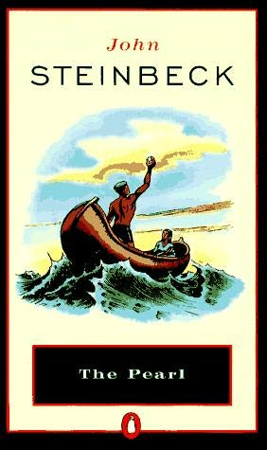

***The assignment will also be posted on the school website on the King High School homepage.***

IB-9th Summer Reading

***Name:____________________________________________________ Date:___________________***

***The Pearl* by John Steinbeck**

**MC900351225[1]**

**Summer Reading Assignment**

**Directions:** Complete the following reading comprehension questions as you read each chapter in *The Pearl.* ALL WORK MUST BE TYPED, 12 PT FONT, DOUBLE SPACED.

This assignment is due August 10, 2021 (Day 1) and August 11, 2021 (Day 2)

**CHAPTER 1**

1. Who are the three important characters?
2. Describe each character using at least 2-3 details.
3. What kind of lifestyle do they have?
4. What evidence of belief in superstition can you find?
5. Copy examples from the novel that show the author’s use of description. Cite page #s.
6. With what event in this chapter does the real action of the story begin?
7. Describe how Kino’s life is symbolized in “songs.” What contrasting songs are emphasized at different times?
8. What is the difference between the “city of grass huts” and the “city of stone”? How are we made aware of the difference (quote)?
9. In chapter one, we meet the doctor. Three different characterizations of the doctor are suggested. Distinguish between them: (all three should be different even if only slightly)
   * The doctor as seen by the beggars
   * The doctor as seen by himself
   * The doctor as seen by Kino

**CHAPTER 2**

1. Use at least three details (quotes) about the town to make inferences about the lifestyle of the villagers. Cite page #s and say what is inferred.
2. What object of great value had Kino’s grandfather brought from Nayarit, and why was it so valuable?
3. How are pearls created by oysters (quote)?
4. Describe, in detail, how Kino searched for pearls.
5. Why do Kino’s people sing songs? Give an example of a song, and tell why it was sung.
6. Why does Kino want to save one particular oyster to open last?
7. After Kino finds the great pearl, what happens to Coyotito?
8. In the selling the pearl, what disadvantages and advantages did Kino have? Include at least one for each)
   * disadvantages
   * advantages

**Chapter 3**

18. To what does Steinbeck compare the town?

19. The news of Kino's pearl spread quickly across town. What did each person think of when he

heard it?

20. What would Kino do with his riches?

21. Why does the doctor come? What does he do?

22. What bad thing happened to make Juana want to throw away the pearl?

**CHAPTER 4**

23. Explain the public attitude the dealers had toward Kino and his “Pearl of the World”? Why was it different than their private attitude (what they thought behind Kino’s back)?

24. What did the townspeople think Kino should do with his “Pearl of the World”? Why?

25.By the end of Chapter 4, what decision had Kino reached concerning what to do with the pearl? Was he right or wrong to do what he did? Why?

**CHAPTER 5**

26. With what important incident did this chapter begin?

27. What incident in this chapter put peace behind Kino and Juana forever?

28. What additional event(s) made it impossible for Kino and Juana to remain in the village?

29. How did Kino and Juana spend their last day in the village?

30. By the end of this chapter, the pearl has become a moral issue to Kino. How does he express it (quote)? How do you explain it?

**CHAPTER 6**

31. How does the author describe Kino at the beginning of this chapter?

32. This chapter might be subtitled “the flight.” Trace it through the important incidents that happened. List at least 4 things.

33. Describe the return of the family to the village.

34. What was Kino’s final action? Why?

35. Now that you have finished reading the book, explain why the foreword says this story might be a parable (fable/tale)?